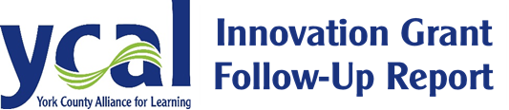

Please complete the following report within 30 days of the completion of your Grant Project. This summary, along with a statement of your financial expenditure may be emailed to info@ycal.us when completed.

Grant Project Summary
Name(s):
Project Title:
School District:
School Building(s):
Business/Community Organization Partner(s):
Total Students Impacted:
Total Educators Involved:
Total Amount Expended:
Project Outcomes:
(Please describe the outcomes of the project based on the assessment method(s) mentioned in your application as well as the student experiences in working with the Business Partner)

Electronic Version available for download at www.ycal.us/innovation-grants

